11.1 Acids and bases
Name: ____________________ Class: ____________________ Due date: 12.29
1. Which substance is the most acidic? （ ）
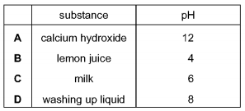
2. Different plants grow best under different pH conditions.
Which plant grows worst in acidic soil? （ ）
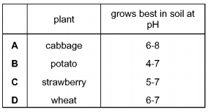

3. The graph shows how the pH of soil in a field changes over time.
At which point was the soil neutral? （ ）
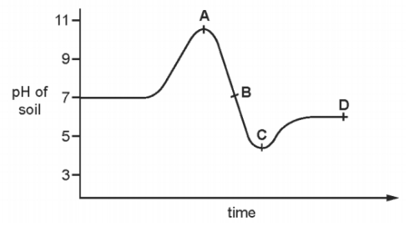

4. Which of the following solution has the highest concentration of H+ ? （ ）
A. HCl(aq) with ph of 2 B. H₂SO₄ with ph of 3 C. NaOH with ph of 9

5.Which of the following solution shows the lowest acidity? （ ）
A. HCl solution with ph of 2
B. CH₃COOH solution with ph of 3
C. Na₂CO₃ solution with ph of 8
D. NaOH solution with ph of 14

6. Carbonic acid is a weak acid formed when carbon dioxide dissolves in water.
What is the pH of the solution? （ ）
A 1 B 5 C 7 D 9

7.(Extension).
A sting from insect X has a pH of 6 and a sting from insect Y has a pH of 8.
The table shows the pH of four substances.
The effect of acidic substances can be canceled by substance with ph higher than 7
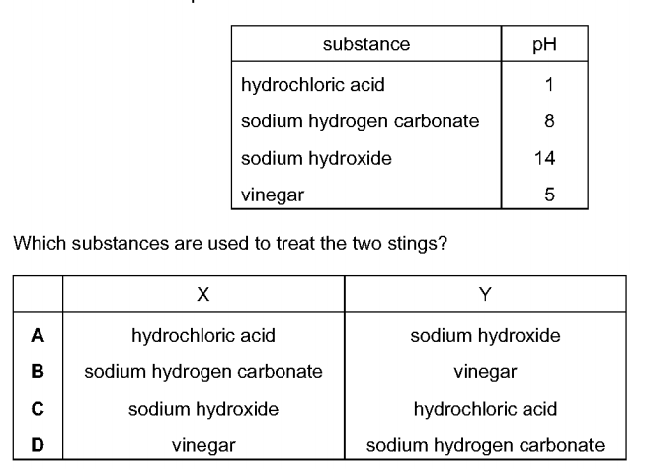
Which substances are used to treat the two stings? （ ）

8. Solution A has a higher concentration of H⁺ ions than solution B does.
Which has a higher pH, A or B?

9. Solutions of acids X and Y have the same concentrations.
X has pH 2.5. Y has pH 5.3. Which one is a weak acid?

10. A solution of a strong acid has a pH of 2.
How will the pH change when you add more water? Explain your answer.

11. Ammonia is a compound which only contains the elements nitrogen and hydrogen.
Define the term base.

